CAMPUS OBERT
ACCESS INSTRUCTIONS

CREATING A USER ACCOUNT

1. Go to: https://campusobert2.ub.edu/login/index.php

2. At the bottom of the page, click “Create new account”

Compete the registration form with the required information
a. User name
b. Password
c. E-mail address (confirmation required)
d. Surname(s)
e. First name
f. City
g. Country

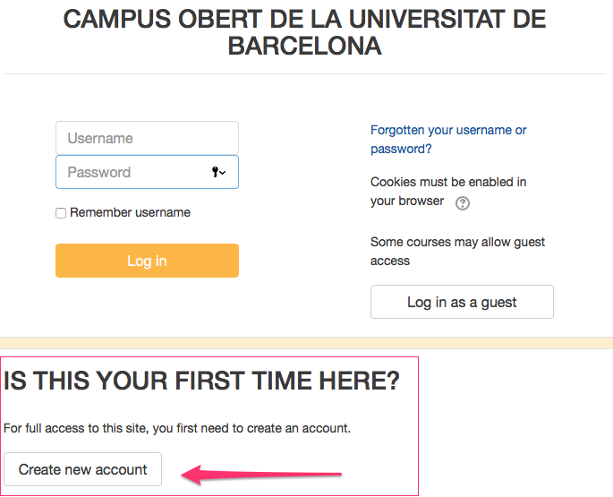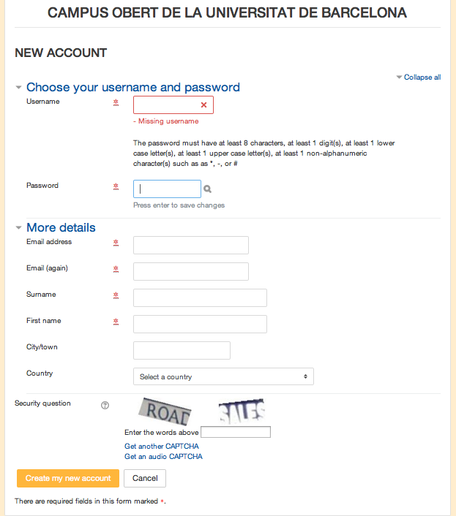

3. Confirm your e-mail address and registration on the platform.

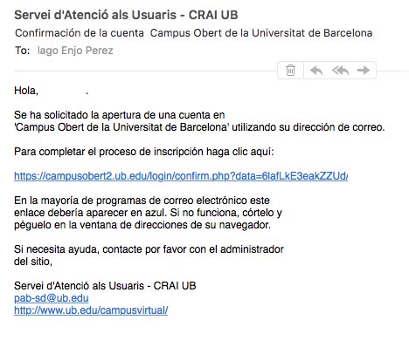

4. Go to: https://campusobert2.ub.edu/course/view.php?id=4130

In “Self enrolment (Student)”, type in the code RACE2017

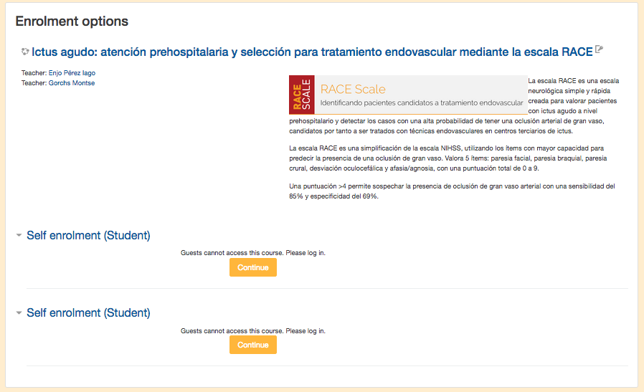

To watch the course videos you may need to install http://www.microsoft.com/getsilverlight/

And update http://www.java.com/es/download/

